Art ‘All Around the World Week’ w/c 3rd July
Please could you use the artist and the LO’s below for your year group and focus on a painting element on the whole school theme of Africa.
Year group | Artist | Learning Objectives
Reception | Esther Mahlangu  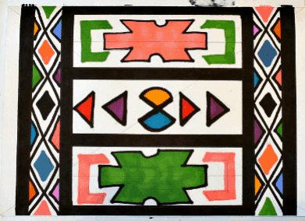 | - Use a range of small tools, including scissors, paint brushes and cutlery  - Safely use and explore a variety of materials, tools and techniques, experimenting with colour, design, texture, form, and  - Share their creations, explaining the process they have used;
Year 1 | 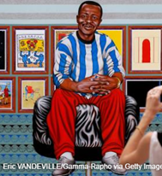  Cheri Samba | • Use and experiment with a variety of tools and techniques including the use of different brush sizes and types  • Mix and match colours to artefacts and objects.  • Mix a range of secondary colours, shades and tones.  • Work on different scales e.g. large brush on large paper etc  • Name and use different types of paint.
Year 2 | Thandive Muriu  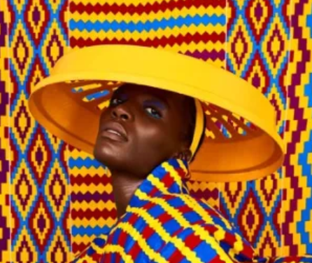
Year 3 | Enfant Precoce  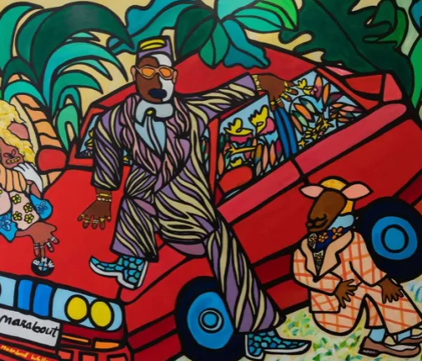 | • Use a developed colour vocabulary e.g. tint, tone, shade, hue.  • Choose paints and implements appropriately  • Plan and create with different effects and textures inc. blocking in colour, washes, thickened paint etc.  • Work confidently on a range of scales e.g. thin brush on small picture etc.
Year 4 | Blessing Ngobeni 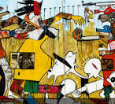
Year 5 | Nadir Babayev  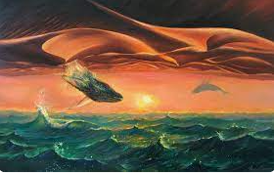 | • Demonstrate a secure knowledge about primary and secondary, warm and cold, complementary and contrasting colours.  • Work on preliminary studies to test media and materials.  • Create imaginative work from a variety of sources.  • Show an awareness of how paintings are created (composition).  • Choose appropriate paint, paper and implements to adapt and extend their work.  • Work from a variety of sources, inc. those researched independently.
Year 6 | Abdoulaye Konate  

