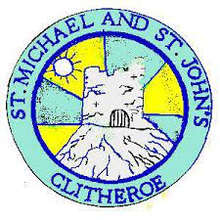

St Michael & St John’s G.I.F.T. Team (Growing in Faith)
Minutes
Date: 22.5.24
Present: Joe P, Robyn, Heidi, Leo, Josh, Molly, Ellie, Mr Cross
Other:
Prayer chosen by: Molly (Hail Mary) | Next week: Robyn
Child led worship | Feedback from observing different year groups worship sessions:  - Robyn: I liked in year 3 how they all came and sat on the carpet and were really engaged with the worship.  - Robyn - Year 1 – they were really independent.  - I loved the layout in Year 2 how  - Leo – I really appreciated how they saved a seat for me and included me in their worship.  - Joe P – Children are using the vocabulary – We gather etc.  - Every year group, they had their do not disturb sign on.  - Robyn – Mr Gaughan gave me my own chair and I was able to have my own worship before everyone else.  - Molly – In EYFS they really understood the structure of a worship.
Mary’s Mail | Mary’s Mail distributed. GIFT team to follow up the amount of mail for Mary. Josh and Molly to report back.
GIFT Team Applications | Next steps to work alongside new Year 5 GIFT Team members for Summer 2.
Month of Mary Club | To start on Tuesday 7th May.  GIFT team to go into each class on 2.5.24 to encourage children to attend.
Liturgy & Mindfulness | Mindfulness for Mary. Thoughts:  - It was really nice. It was really nice how Mrs Mabbott did it after lunch.  - Mrs Mabbott allowed everyone to get comfortable and we were able to sit wherever we wanted.  - I liked the link to the Celebration of the Word.
Bible Band | Josh, Joe P and Leo – Year 5 and 6.
Following the example of Jesus, together we learn, love and respect one another
to be the best we can be.

